**DBMS ASSIGNMENT**

**Question:**

Create an application for student contacts management application. The application enables a faculty user to login and search the details of a **Student** (Name, Address, Contact no, Email id, parent contact) with his register number. Create necessary tables and Forms.

Akash Ambashankar

CSE 4A

311018104005

**Data Schema:**

1. Accounts Table

|  |  |  |
| --- | --- | --- |
| **Name** | **Username** | **Password** |
| TEXT | TEXT PRIMARY KEY | TEXT |

1. Student Table

|  |  |  |  |  |  |
| --- | --- | --- | --- | --- | --- |
| **Name** | **Register_Number** | **Address** | **Contact_Number** | **Email_Id** | **PCN** |
| TEXT | NUMBER PRIMARY KEY | TEXT | NUMBER | TEXT | NUM |

**Form Design:**

* + 1. Main

import PySimpleGUI as s

from Log_In import login

from Sign_Up import signup

col = "#343434"

col2 = "white"

layout = [

[s.Text("Student Contact Manager", background_color=col, justification="left", text_color=col2)],

[s.Text("", background_color=col, text_color=col2)],

[s.Button("Log In", button_color=('white', 'black')), s.Button("Sign Up", button_color=('white', 'black'))]

]

w = s.Window("Student Contact Manager", layout, background_color=col, use_default_focus=False, element_justification="center")

while True:

button, values = w.Read()

if button == "Log In":

w.Close()

login()

break

if button == "Sign Up":

w.Close()

signup()

break

if button is None:

w.Close()

break

* + 1. Log In

import PySimpleGUI as s

from Sign_Up import signup

from back import *

from Search import search_page

def login():

col = "#343434"

col2 = "white"

login_layout = [

[s.Text("Student Contact Manager", font='courier' '50', background_color=col, justification="left", text_color=col2)],

[s.Text("Username", background_color=col, text_color=col2), s.InputText("", key='username',size=(20,10))],

[s.Text("Password", background_color=col, text_color=col2), s.InputText("", key="password", password_char='*', size=(20,10))],

[s.Button("Login", bind_return_key=True, button_color=('white', 'black'))],

[s.Text(" ", key='msg', background_color=col)],

[s.Text("Don't have an account?",background_color=col, text_color=col2),s.Button("Sign Up",button_color=('green',col),border_width=0)]

]

w = s.Window("Login", login_layout, resizable=1, background_color=col, element_justification="center")

while True:

button, values = w.Read()

if button == "Login":

if authenticate(values['username'], values['password']):

w.FindElement('msg').update("Logging in...", text_color='green')

w.Close()

search_page()

else:

if values["password"] == "":

w.FindElement('msg').update("Password required", text_color='red')

else:

w.FindElement('msg').update("Username or password is incorrect", text_color='red')

if button == "Sign Up":

w.Close()

signup()

if button is None:

w.Close()

break

* + 1. Sign Up

import PySimpleGUI as s

from back import *

import Log_In

col = "#343434"

col2 = "white"

def signup():

sign_up_layout = [[s.Text("Student Contact Manager", font='courier' '50', background_color=col, justification="left", text_color=col2)],

[s.Text("Enter Name ", background_color=col,

text_color=col2), s.InputText("", key='name', size=(20,10))],

[s.Text("Enter Username ", background_color=col, text_color=col2), s.InputText("", key='username', size=(20,10))],

[s.Text("Enter Password ", background_color=col, text_color=col2), s.InputText("", key="password", password_char='*', size=(20,10))],

[s.Text("Confirm Password", background_color=col, text_color=col2), s.InputText("", key="cpassword", password_char='*',size=(20,10))],

[s.Text(" ", key='msg', background_color=col)],

[s.Button("Create Account", bind_return_key=True, button_color=('white', 'black'))],

[s.Text("Already have an account?", background_color=col, text_color=col2),

s.Button("Log In", button_color=('green', col), border_width=0)]]

sign_w = s.Window("Sign Up", sign_up_layout, resizable=1, background_color=col)

while True:

s_button, s_values = sign_w.Read()

if s_button == "Create Account":

if s_values['password'] == s_values['cpassword']:

if len(s_values['password']) > 7:

ifcreate_acc(s_values['name'],s_values['username'], encrypt(s_values['password'])):

sign_w.FindElement('msg').update("Account Created", text_color='green')

else:sign_w.FindElement('msg').update("Username Taken", text_color='red')

else:sign_w.FindElement('msg').update("Password too short", text_color='red')

else:sign_w.FindElement('msg').update("Passwords do not match", text_color='red')

if s_button == "Log In":

sign_w.Close()

Log_In.login()

break

if s_button is None:

sign_w.Close()

break

* + 1. Search

student = []

col = "#343434"

col2 = "white"

layout = [

[s.Text("Student Contact Manager", font='courier' '50', background_color=col, justification="left", text_color=col2), s.Button("Log Out", button_color=("green", col), border_width=0)],

[s.Text("Enter Register Number", background_color=col, text_color=col2)],

[s.Text(" ", key="msg", background_color=col, text_color=col2)],

[s.InputText("", key="reg"), s.Button("Search", button_color=("white", "black"), bind_return_key=True)],

[s.Listbox(student, size=(50, 6), key='box', background_color="white")],

[]

]

w = s.Window("Student Contact Manager", layout, background_color=col, use_default_focus=False)

while True:

button, values = w.Read()

if button == "Search":

try:

details = search(values["reg"])

w.FindElement("reg").update("")

w.FindElement("box").update(details)

w.FindElement("msg").update("")

except:

w.FindElement("msg").update("Invalid Number", text_color="red")

if button == "Log Out":

w.Close()

Log_In.login()

break

if button is None:

w.Close()

break

* + 1. Other Functions

from passlib.hash import sha256_crypt

def encrypt(text):

return sha256_crypt.encrypt(text)

def verify(encrypted, entry):

return sha256_crypt.verify(entry, encrypted)

def clean(list):

return list[0][0]

Screenshots:

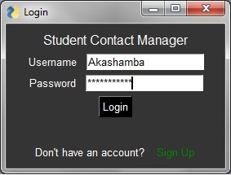

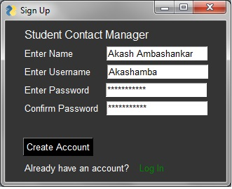

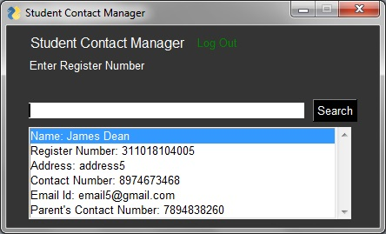

**Source Code:**

import sqlite3

db = sqlite3.connect('contacts_db')

c = db.cursor()

c.execute('''CREATE TABLE IF NOT EXISTS Accounts(Name TEXT, Username TEXT PRIMARY KEY,Password TEXT)''')

c.execute('''CREATE TABLE IF NOT EXISTS Student(Name TEXT, Register_Number INTEGER PRIMARY KEY, Address TEXT, Contact_Number INTEGER,

Email_ID TEXT, Parent_Contact_Number INTEGER)''')

db.commit()

def create_acc(name, username, password):

try:

c.execute('''INSERT into Accounts(Name, Username, Password) VALUES(?,?,?) ''', (name, username, password))

db.commit()

return True

except:

return False

def delete_acc(username):

c.execute('''delete from Accounts where Username=?''', (username,))

db.commit()

def authenticate(username, password):

try:

c.execute('''select Username from Accounts where Username=?''', (username,))

x = clean(c.fetchall())

c.execute('''select Password from Accounts where Username=?''', (username,))

y = clean(c.fetchall())

db.commit()

if username == x and verify(y, password):

return True

except:

return False

def search(reg):

details = []

columns = ["Name:", "Register Number:", "Address:", "Contact Number:", "Email Id:", "Parent's Contact Number:"]

c.execute('''select * from Student where Register_Number=?''', (reg,))

x = c.fetchall()

for i in range(len(x[0])):

details.append(str(columns[i]) +" "+ str(x[0][i]))

return details